National Society of Professional Surveyors
and
Wisconsin Society of Land Surveyors
Award This Certificate Of Participation To
«Student»
In Recognition of Your Participation In
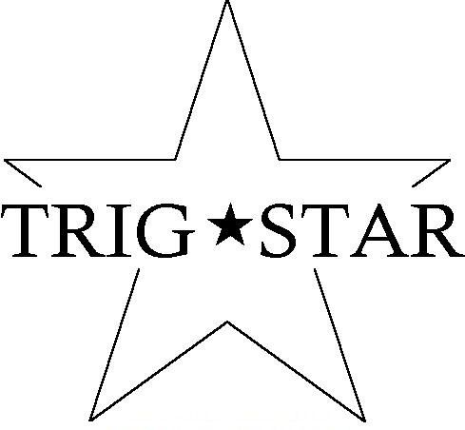  2015 2016 | TRIGSTAR  COMPETITION
«Teacher»
Teacher
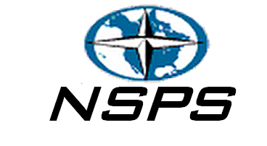 | «Sponsor»  Sponsor

