CHIPPEWA NATIONAL FOREST, EASTERN REGION
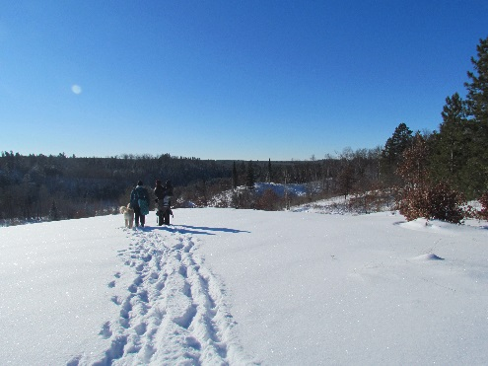
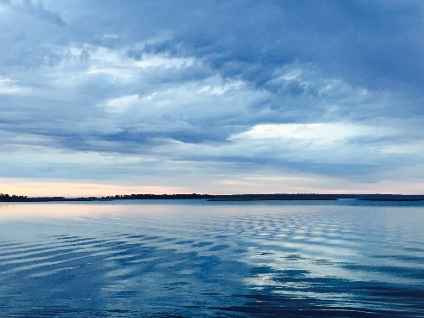
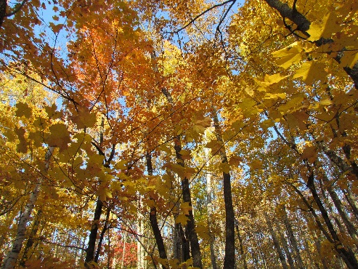

OUTREACH NOTICE
Land Surveyor
GS-1373-11/12
Duty Station: Cass Lake, MN
November 31, 2023 – December 08, 2023

The USDA Forest Service, Chippewa National Forest is seeking candidates for a Permanent Full-Time Land Surveyor. The duty station is in Cass Lake, MN. The position will have Regular Telework authorized. If you have any questions about this position, please contact Liz Schleif at 218-335-8637 or by email at Elizabeth.Schleif@usda.gov. To ensure you notified when this position will be advertised, you must respond in the outreach database. Please respond by December 08, 2023. You may apply for the vacancy even if you do not respond to the outreach – the outreach ensures that your interest is documented.

FS Internal:
Land Surveyor

Public:
Land Surveyor

The purpose of this outreach is to determine the potential applicant pool for the positions and to establish appropriate recruitment methods and areas of consideration for the vacancy announcement. This position will be advertised competitively in USAjobs from December 14th through December 20th. The hiring manager is considering the following with proof of your eligibility:

- Current Federal Employee through Reassignments (lateral)
- Resource Assistants
- Peace Corps Personnel
- Veterans Recruitment Appointment (VRA)
- 30% or more Disabled Veteran, and
- Schedule A authority for hiring people with “severe” disabilities

Information about eligibility can be found here: USAJOBS Help Center | Which jobs am I eligible to apply for?

The incumbent will serve as the boundary and title program manager for the Chippewa National Forest, reporting to the Public Services staff officer in a team that includes realty, engineering, heritage and recreation. The land surveyor is responsible for cadastral surveys to support natural resource management activities such as timber sales. Surveys may be accomplished in-house or through contracting. The land surveyor also works closely with the land adjustment program to research title, prepare legal descriptions, investigate encroachments and resolve title claims.

NOTE - A State Land Surveyor registration for Minnesota will be required within one year of selection.

Major Duties
- Plans, conducts, and/or oversees district survey projects of a complex nature. These usually involve conflicting title data or fragmentary corner evidence requiring considerable research and evaluation and the proper application of pertinent State and Federal laws.
- Serves as a registered land surveyor within the State the Forest Service unit is located. Provides technical assistance and guidance on problems involving boundary disputes that include making recommendations in administrative procedures, survey methods, evidence evaluation, legal interpretation and corner restoration consistent with Forest Service policy, standards, and state laws.
- Assembles all survey project data and performs the necessary mathematical computations involved in traverse closure, azimuth determination, state plane coordinate transformation, section subdivision, route alignment, and location. Prepares preliminary and final legal records, and title descriptions.
- Consults with the Registrar of Deeds, county surveyors, other registered land surveyors, property owners, Government officials, and all other sources for record information of previous surveys or other data which affect or could affect the location of property lines.
- Serves as Contracting Officer's Representative on survey projects formally contracted to private firms, prepares specifications, and/or reviews surveying contracts on the Forest. Makes inspections for compliance with technical engineering and contractual requirements. Upon completion of contracts, recommends approval of final payments to the Contracting Officer.
- Serves as a Project Manager responsible for the overall management, control, coordination, and execution of assigned projects. As the project team leader, implements corporate decisions, guidance, laws, regulations, and policy in the development of projects. Negotiates and integrates all Forest Service unit functions such as planning, design, cost engineering, contract administration, real estate, and contracting, to meet sponsor/customer requirements, and interagency commitments.
- Independently prepares detailed scopes of work, or provides templates, guidance, and reviews scope of work prepared by others. Participates in the unit’s programming decisions affecting long and short range courses of action for assigned projects. Provides input to the Forest Service unit’s operating budget related to projects assigned.
- Serves as a lead for the preparation, negotiation, and administration of task orders to obtain various contracting services depending upon the needs of a particular project. Contracting services include: conducting planning studies and preliminary investigations; performing a broad range of engineering evaluations and assessments; preparing technical reports; preparing detailed plans and specifications; technical review; surveying and mapping; model studies; hydraulic and hydrologic analysis; cost engineering; and other engineering services.
- Performs other duties as assigned.

SUPERVISORY RESPONSIBILITIES:
- Performs supervisory duties at least 20% or less of the time.
- Plans the work to be accomplished by the unit, assigns work to employees, and establishes production or quality standards for the unit’s work. Establishes and communicates guidelines and performance requirements to employees; conducts formal performance reviews; and identifies and provides for the developmental and training needs of employees. Hears and resolves employee complaints, effects minor disciplinary measures, and recommends action in more serious cases. Performs administrative and human resources management functions for the unit; provides advice, counsel or instruction on both administrative and work matters; and assures full compliance with safety regulations.
- Promotes equal opportunity and employs nondiscriminatory practices for merit promotion, recruitment and hiring of applicants; encouragement, recognition and fair treatment of all employees; and career development and full utilization of employees’ skills. Adheres to nondiscriminatory employment practices regarding race, color, national origin, age, disability; and where applicable, sex, marital status, familial status, parental status, religion, sexual orientation, genetic information, political beliefs, reprisal; or because all or part of an individual’s income is derived from any public assistance program.

Please see the USDA Forest Webinar links below for helpful information when applying for federal jobs:

- Tips for Job Seekers
- Hiring Eligibility and Qualifications
- How to Write a Federal Resume
- Navigating USAJOBS.gov

About the Forest Service
Forest Service mission: To sustain the health, diversity, and productivity of the Nation's forests and grasslands to meet the needs of present and future generations.
Grounded in world-class science and technology– and rooted in communities–the USDA Forest Service balances the short- and long-term needs of people and the land. As a Federal agency in service to the American people, the Forest Service cares for shared natural resources in ways that promote lasting economic, ecological, and social vitality and connects people to nature and each other.

Learn more about the Forest Service here.

About the Forest
The Chippewa National Forest is located in north central Minnesota, approximately 200 miles northwest of Minneapolis/St. Paul, and encompasses about 1.6 million acres which includes approximately 666,600 acres of checkerboard ownership with other public, private, and tribal lands interspersed. The Forest Supervisor’s office is located in Cass Lake, MN, with district offices in Blackduck, Deer River and Walker. The Forest was the first National Forest established east of the Mississippi River in 1908 and has a rich cultural history spanning at least 10,000 years including pre-European contact sites, logging camps, and Ojibwe and Euroamerican homesteads. Over 40% of the Forest is within the Leech Lake Indian Reservation and forest employees coordinate and consult closely with the Leech Lake Band of Ojibwe.

Water is very abundant on the National Forest and includes the Mississippi River headwaters region along with over 1300 lakes, 923 miles of rivers and streams, and 400,000 acres of wetlands providing world class fishing opportunities to visitors. Mixed northern conifer and hardwoods blanket the rolling uplands of the Chippewa. Recreation opportunities abound with canoeing, camping, boating, swimming, hiking, biking, horseback riding, cross-country skiing, snowmobiling and scenic drives throughout the area.

For further information about the Forest, see our website: https://www.fs.usda.gov/Chippewa

DUTY LOCATION

Cass Lake, MN
Cass Lake is located four and a half hours north of the Twin Cities in North Central Minnesota. Cass Lake is home of the Chippewa National Forest, Leech Lake Band of Ojibwe, and five of Minnesota's largest lakes. The Ojibwe offer many colorful Pow-Wow celebrations that are open to the public and operate three casinos, offering a variety of gaming experiences and ethnic foods. Cass Lake Chamber of Commerce

SURROUNDING COMMUNITIES
Bemidji, MN
Bemidji has a city population of 15,404, and is a regional center, serving over 100,000 northern Minnesota residents. It’s a university town with arts and cultural activities as well as recreational opportunities year-round. Bemidji Chamber of Commerce

In accordance with Federal civil rights law and U.S. Department of Agriculture (USDA) civil rights regulations and policies, the USDA, its Agencies, offices, and employees, and institutions participating in or administering USDA programs are prohibited from discriminating based on race, color, national origin, religion, sex, gender identity (including gender expression), sexual orientation, disability, age, marital status, family/parental status, income derived from a public assistance program, political beliefs, or reprisal or retaliation for prior civil rights activity, in any program or activity conducted or funded by USDA (not all bases apply to all programs). Remedies and complaint filing deadlines vary by program or incident.
Persons with disabilities who require alternative means of communication for program information (e.g., Braille, large print, audiotape, American Sign Language, etc.) should contact the responsible Agency or USDA's TARGET Center at (202) 720-2600 (voice and TTY) or contact USDA through the Federal Relay Service at (800) 877-8339. Additionally, program information may be made available in languages other than English.
To file a program discrimination complaint, complete the USDA Program Discrimination Complaint Form, AD-3027, found online at How to File a Program Discrimination Complaint and at any USDA office or write a letter addressed to USDA and provide in the letter all of the information requested in the form. To request a copy of the complaint form, call (866) 632-9992. Submit your completed form or letter to USDA by: (1) mail: U.S. Department of Agriculture, Office of the Assistant Secretary for Civil Rights, 1400 Independence Avenue, SW, Washington, D.C. 20250-9410; (2) fax: (202) 690-7442; or (3) email: program.intake@usda.gov.
USDA is an equal opportunity provider, employer, and lender

